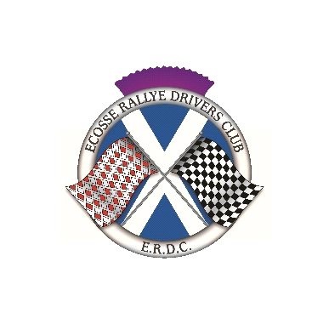

**ECOSSE RALLYE DRIVERS CLUB**

**Membership** **Application/Renewal**

Fill in your details and post or email this form to the address below.

Name:

Address:

Email address:

Telephone number:

I hereby apply for Membership of the above Club, and agree to be bound by its Rules, a copy of which I know I may obtain from the Club Secretary, or on the ERDC tab of the [www.monte.scot](http://www.monte.scot/) website. Membership is for the calendar year and due for renewal by 30 January each year.

Signature: Date:

**Annual** **Membership** **Subscription:** **£15.00**

Please make cheques payable to ‘Ecosse Rallye Drivers Club’

or by bank transfer to

Ecosse Rallye Drivers Club

Santander

Sort Code 09 01 29

Account number 38813548

If transferring funds, please use your name as the reference.

Your details will be held on a data base but will not be passed on to a third party.

Alan Brisbane

21 Bartie Gardens

Ashgill

South Lanarkshire

ML9 3FB

[alan.brisbane1@hotmail.com](mailto:alan.brisbane1@hotmail.com)